Top of Form

Instruction: Identify the entities and relationships that exist in this problem. Draw an equivalent enhanced- ER diagram. Write your answers in a PDF file and submit them on this assignment page.

**GROUPWORK**

A technology company provides offerings to its customers. Offerings are of two separate types: products and services. Offerings are identified by an offering ID and an attribute of description. In addition, products are described by product name, standard price, and date of the first release; services are described by name of the company's unit responsible for the service and conditions of service. There are **repair**, maintenance, and other types of services.

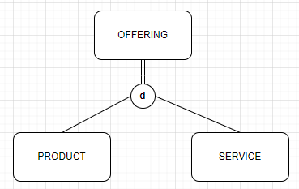

**Offering**

OFFERING_ID

DESCRIPTION_ID

**Product**

PRODUCT_NAME

STANDARD_PRICE

FIRST_RELEASE_DATE

**Service**

COMPANY_UNIT_NAME (FK)

// SERVICE_TYPE

{CONDITIONS}

A repair service has a cost and is the repair of some product; a maintenance service has an hourly rate. Fortunately, some products never require repair. However, there are many potential repair services for a product. A customer may purchase an offering, and the company needs to keep track of when the offering was purchased and the Contact person for that offering with the customer. Unfortunately, not all offerings are purchased.

**Service**

Repair

Maintenance

Customers are identiﬁed by customer ID and have descriptive data of name, address, and phone number. When a service is performed, that service is billed to some customer. Because some customers purchase offerings for their clients, a customer may be billed for services he or she did not purchase, as well as for ones that were purchased. When a customer is billed for service (although some may never require service of any type**), the company needs to keep track of the date the service was performed, the date the bill is due, and the amount due.**

**Customer**

CUSTOMER_ID

CUSTOMER_NAME

CUSTOMER_ADDRESS

CUSTOMER_PHONENUMBER

**Company**

COMPANY_NAME

SERVICE_DATE

Service – Customer

Bottom of Form